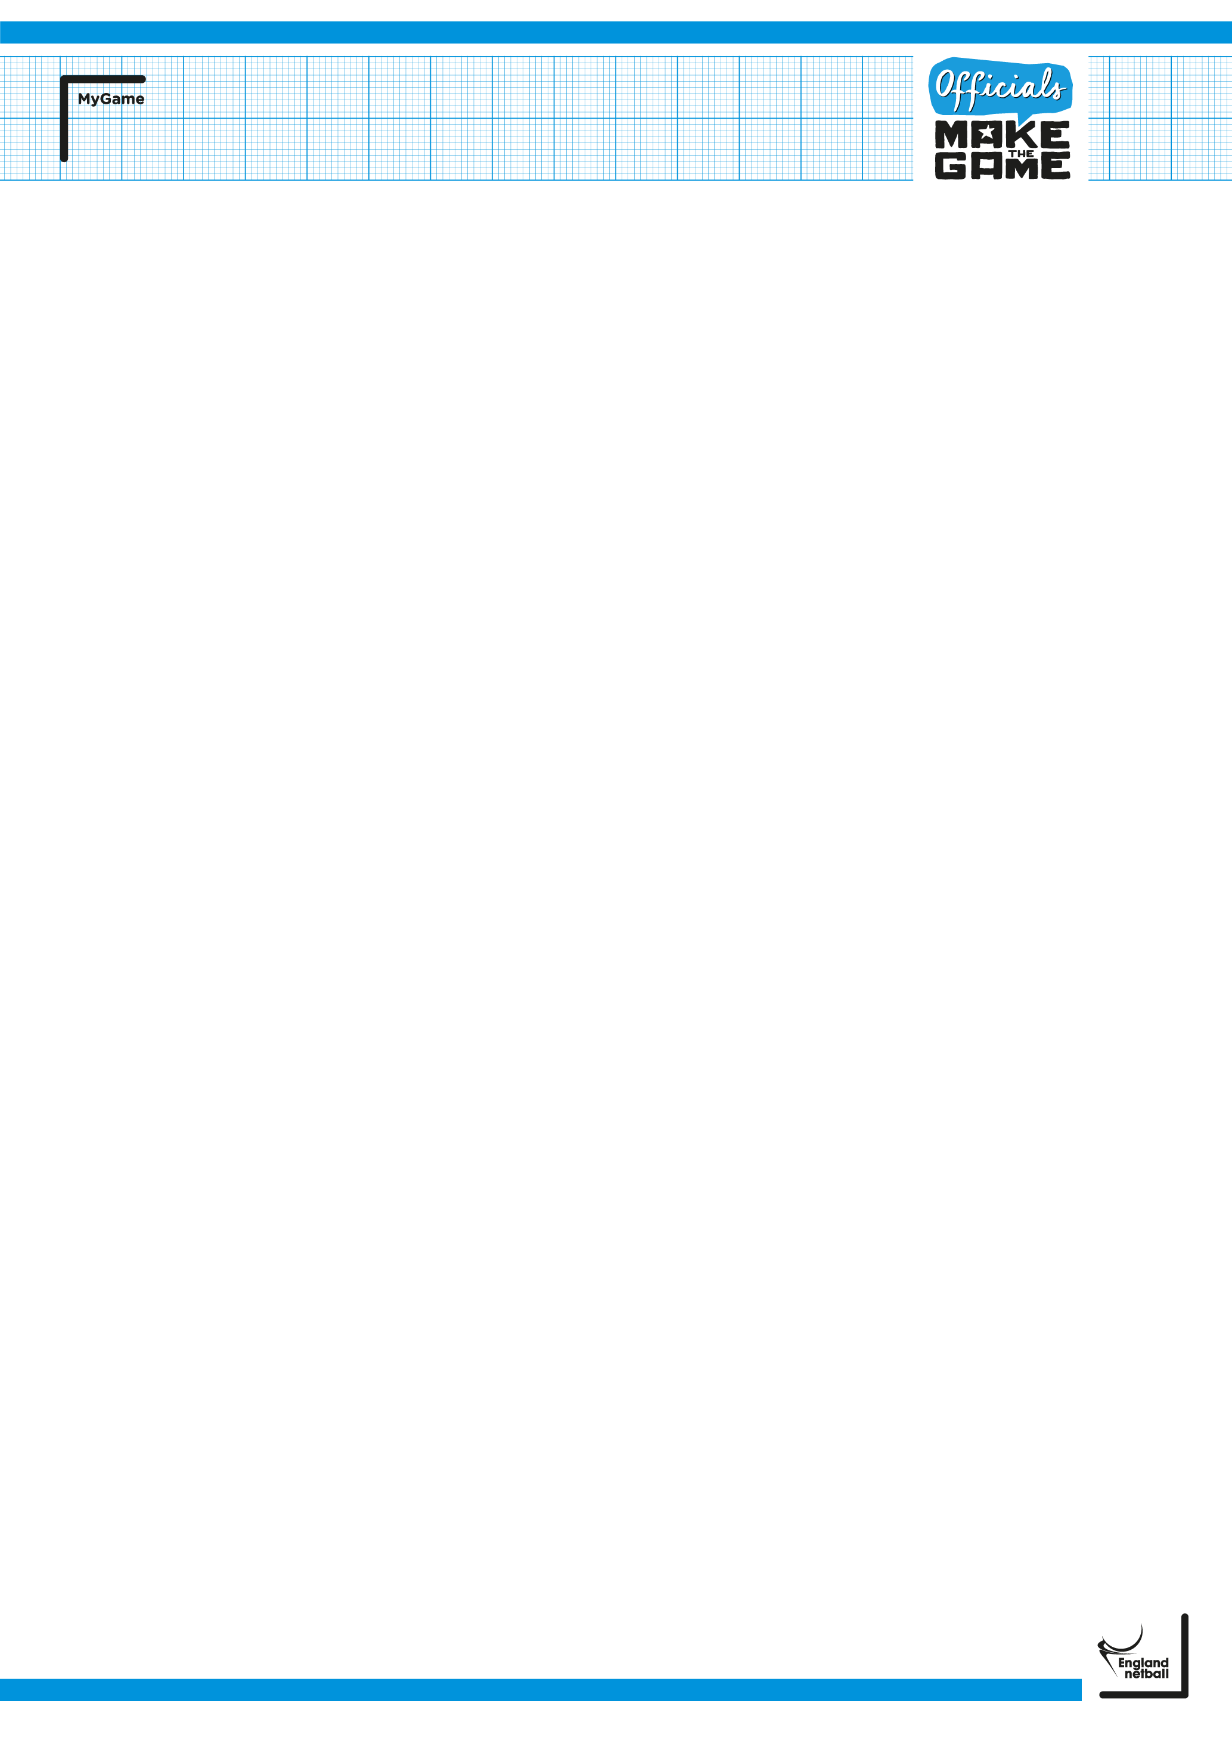
Extension of the England Netball INTO Officiating Award due to COVID-19

To ensure a consistent approach, England Netball have adopted the directive on extensions to awards and written assessments as outlined by Netball Europe.

Attended an INTO course and not applied for INTO practical assessment

Ordinarily learners have 2 years from the date that they attended an INTO course in which to take their practical assessment. 22 months should be added to any expiry date related to course attendance. For example, a course attendance expiry of April 30th, 2020 will now be extended to February 28th, 2022.

Application for INTO practical assessment

All applications for practical assessments that have already been submitted to a county organiser will remain valid. From the 1st of September 2021, organisers will be required to arrange the INTO assessment within 6 months (currently 1 month) pending review.

Validity of the INTO award

The INTO award is currently valid for 4 years. Any expiry date that falls between the period 16th March 2020 and August 31st, 2021 will be extended by 22 months. For example, an INTO qualification expiry of April 30th, 2020 will now be extend to February 28th, 2022.
Assessments on the Modified Game
As you may have noted from other communications sent Netball Europe has advised that it is not possible to assess learners for their C, B and A Award pre or final practical assessments on the modified game. Please note that for reasons outlined and for purposes of maintaining consistency, assessments for the Into Officiating Award will not be permitted on the modified game. Whilst the two formats do not vary a great deal the impact on learners and the requirement for alternate focus is likely to impact on the umpire and their ability to meet the standards set out in the Into Officiating Award umpire assessment competencies.
With this in mind and the extensions given by England Netball, learners are advised to use the extensions open to them and refocus on completing their officiating pathway once the modified game is removed on 21st June 2021.

